User Manual

HR sourcing

Version 1.0

May 22, 2020

|  |  |  |  |
| --- | --- | --- | --- |
| **Document ID:** |  | **Release:** |  |
| **Revision#** | 1.0 | **Revision Date:** |  |
| **Next Revision Due:** |  | **Information Sensitivity:** | Confidential |

Document Details

|  |  |
| --- | --- |
| Solution Document | |
| Project owner | **Xiaomi Technology India Private Limited** |
| Project title | HR Sourcing & Tracking |

|  |  |  |  |  |
| --- | --- | --- | --- | --- |
| Review Tracking | | | | |
| Version | **Description** | **Prepared by** | **Role** | **Date** |
| Version 1.0 | Initial Draft | Priyank Piyush/ Gokul Sola | Solution Architect/ Developer | 23-May-20 |

Contents

Document Details 2

1. Introduction 4

2. Applications 5

3. Files & Folders 6

3.1. Inputs & Formats 6

3.1. Folder Structure (High Level) 6

3.2. Configuration 7

3.3. Input ( Desktop Tracker ) 8

3.4. 2_Processing 8

3.5. Output ( 3_Consolidated ) 9

3.6. 4_Resume 10

2.9 Job Description 10

4. Checks/Steps executing Bot 11

5. Exception / Logs 12

6. Tables, Queries and Stored Procedure in Database 13

6.1. Table List (Tables to be created in Database) 13

6.2. Stored Procedure 13

7. Audit and Error Logs 14

1. Introduction

This document is intended to provide Business User and Technical Support team, go to manual for errors/Bugs encountered during running the solution.

Below table describes the process on high level.

|  |  |
| --- | --- |
| **Attribute** | **Description** |
| Business Scope | Sourcing and Tracking Candidate profiles |
| Job Portals | IIM Jobs, Naukri.com, Hirist.com, Internshala |
| Process Output | Stage 1: Sourcing Resume or Candidate Profile and Posting Requirements  Stage 2: Tracking in Report |
| Frequency | Daily ( Midnight to 1 AM ) |
| Transaction Volume | 10 – 20 Requirement / Day |
| Time Sensitivity | Candidate resume needs to be sourced as soon as possible |
| Dependencies | Candidate Status update and Sourcing details (Needs to be inputted manually be HR Team) |
| Failure Implications | Increase in effort, Delay in recruitment. |
| Process Criticality | Medium |
| Expected time for process to run | 1 Hour per Run |

1. Applications

|  |  |  |  |
| --- | --- | --- | --- |
| **S. No.** | **Application Names** | **Version and Type** | **Description** |
| 1 | Outlook | Office 365 | Sending respond emails. |
| 2 | Excel | Office 365 | Validate and update the Requirement and Candidate Tracker |
| 3 | Naukri.com | Website | Search and Post requirement on Portal |
| 4 | IIM Jobs .com | Website | Search and Post requirement on Portal |
| 5 | Hirist.com | Website | Search and Post requirement on Portal |
| 6 | Internshala.com | Website | Post job requirement on the Internshala portal |

1. Files & Folders
   1. Inputs & Formats

|  |  |  |
| --- | --- | --- |
| **S. No.** | **Input Name** | **Purpose** |
| 1 | Requirement Tracker | Requirements to search for Candidates |
| 2 | Candidate Tracker | To maintain Candidate Details. |
| 3 | Job Description Document | Job Description to be updated on the websites while Posting a job  **Note :**  Job Description files should be named with the position ID of the requirement |
| 4 | Recruiter Mail And Standard Value | Details of the Recruiters and perks, Company Details required for posting the job |

* 1. Folder Structure (High Level)

Folders for HR Scouring are hosted on : 10.56.158.25 > Share> HR_Sourcing >

Below is the screenshot of folders.

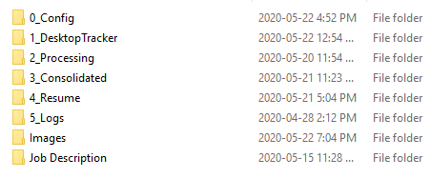

* 1. Configuration

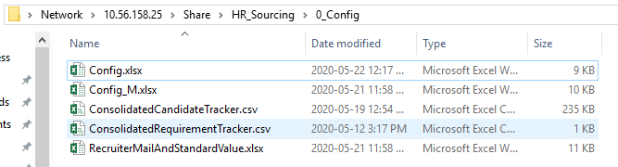

Configuration folder consists of Following files

|  |  |
| --- | --- |
| **File Name** | **Description** |
| Config.xlsx | Configuration file with details of connection string, Email ( Status emails ) etc. |
| Consolidated Candidate Tracker & Consolidated Requirement Tracker | Template file for generating consolidated Condidate and Requirement Trackers |
| Requirement Mail and Standard Value | Email of recruiters and Standard values for Bot reference. |

* + 1. **Configuration File**

**Note:**

* Contains all Default values like DB Connection String, Mail ID’s
* Email Id is used to Trigger status emails.
  1. Input ( Desktop Tracker )
* Input folder/Desktop Tracker : This folder has subfolders with name of each Recruiter

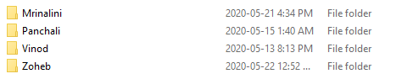

* + 1. **Recuiter Folder ( 1_DesktopTracker > Vinod )**



* Each recruiter folder should contain **Requirement Tracker** and **Candidate Tracker**

**Input in this folder are**

* + - 1. Requirement Tracker <File Name should include> - > Requirement
      2. Candidate Tracker <File Name should include> - > Candidate

* 1. 2_Processing

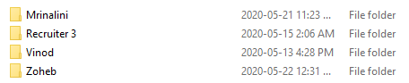Processing folder has same structure as Input folder. The files are stored in this folder in between processing.

* 1. Output ( 3_Consolidated )
     1. 3_Consolidated >

Below screenshot shows the consolidated folder after execution of Bot.

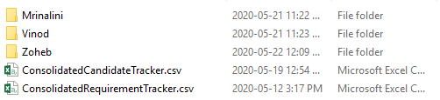

* + - 1. ConsolidatedCandidateTracker.csv - > This CSV file will have details of Candidates data extracted in current run by Bot.
      2. ConsolidatedRequirementTracker.csv -> This CSV file will have details of Requirements extracted in current run by Bot

If we go inside Recruiter folder we will find the Requirement Tracker Updated by Bot for current run.

* + 1. **Output> Vinod**



* 1. 4_Resume

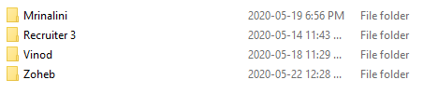

Resume folder has same folder structure as 1_Desktop Tracker with the folders with recruiter’s Name.

**2.8.1 4_Resume > Recruiter**

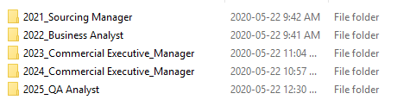

Recruiter folder consists folders with naming format containing PositionID_PositionName of respective requirement created by Bot

**2.8.1 Recruiter > 2021_Sourcing Manager**



PositionID_PositionName Folder contains resumes downloaded for that respective requirement

* 1. Job Description



* + Job Description Folder consists of Job Description documents.
  + Job Description document should be in word format only.
  + File should be named as per position ID as mentioned in Requirement Tracker.

Note: Job Description files should be named with Position Id of respective requirement. The documents should be in .docx format

1. Checks/Steps executing Bot

|  |  |
| --- | --- |
| 1 | Place Input file in Input Folder  Minimum for sourcing > 1 Requirement Tracker & 1 Candidate Tracker |
| 2 | Validate the Format for Input file. (Key fields)   * Recruiter Name (Spelling should be same as folder name ) * Position Id should be unique * Check the Validation in the requirement Tracker |
| 3 | Run the Macro to validate the input in Requirement Tracker. |
| 4 | Review the Config Folder   * Validate if all the Reference tables are updated. |
| 5 | Execute the Bot / Wait for Bots execution at scheduled time. |
| 6 | Review the Audit & Error log |

1. Exception / Logs

|  |  |  |
| --- | --- | --- |
| **Log Type** | **Message** | **Resolution** |
| Login error | (22/5/2020 7:06:18 PM) Naukri Login Error Password Expired | Reset Naukri Password and ask IT team to update the password in Credential Vault. |
| Login error | (22/5/2020 3:18:24 PM) Naukri Login Error OTP Required -> Please Login to Naukri with OTP | Login to Naukri with OTP on Server machine. Request IT team to assistance |
| Login error | (2/1/2020 4:11:08 PM) Login Error Wrong Credentials | Update the Credentials in Control Room |
| Input error | (2/1/2020 7:49:32 PM) Naukri JOB Search Error - > 1 - > PreferredLocation : Aizawl, | Check the value given in requirement tracker and update with the value respective to the portal selected at the reuirement with mentioned position ID |
| Portal Issue | (2/1/2020 4:14:42 PM) IIMJobs JOB Search Error - > 2 - > No Search Results at 78 | When there are no search results for the particular requirement with position ID mentioned . |
| Portal Issue | Naukri JOB Search Error - > 2025 - > Required : 10, No.of Candidates Found : 4, No.of Candidates Sourced : 4 at 103 | When the Search results were less than the Count of Cv’s provided in the requirement tracker |

1. Tables, Queries and Stored Procedure in Database

This section lists the tables and queries being referred by solution.

* 1. Table List (Tables to be created in Database)

|  |  |  |  |
| --- | --- | --- | --- |
| **Sl No** | **Table** | **Table Type** | **Description** |
| 1 | Arch_CandidateTracker | Archive Tables | Archive of CandidateTracker |
| 2 | Arch_RequirementTracker | Archive Tables | Archive of RequirementTracker |
| 3 | CandidateTracker | Input | This table stores candidate details |
| 4 | RecruiterMailDetails | Input | This table stores recruiter Mail ID’s |
| 5 | RequirementTracker | Input | This table stores requirements |
| 6 | Standard | Input | This table stores standard information about company ,perks used to post a job |
| 7 | LogTable | Logs | Stores the detailed log of execution |
| 8 | ErrorLog | Logs | Stores the detailed log of error. |

* 1. Stored Procedure

|  |  |  |  |
| --- | --- | --- | --- |
| **Sl No** | **Queries** | **Table Type** | **Description** |
| 1 | Data_Move | Procedure | This procedure is called by Bot to move data Candidate Tracker to Arch_candidate Tracker table and Requirement Tracker table to Arch_Requirement Tracker table |
| 2 | Data_Test | Procedure | This procedure is called by Bot to test whether the candidate details were are already present in the DB or not |
| 3 | Gender | Procedure | This Procedure is called by Bot to take Gender given requirement tracker and returns the respective ID which is used to select the Gender in naukri Portal |
| 4 | Report | Procedure | This procedure is called by Bot to generate the weekly report saying the details of the resumes downloaded in the last week |
| 5 | Trigger_Task | Procedure | This procedure is called by Bot to trigger the tasks according to the requirement given |

1. Audit and Error Logs

Error Log is available in Logs folder. As shown in Screenshot below.



Logs are also available in Database in the table as mentioned above.